Methodology
The security assessment was conducted in a controlled local environment using a Kali Linux system targeting a PrestaShop instance hosted on 127.0.0.1 on an Apache web server. The assessment followed a structured three-phase approach.
First, a security hardening checklist was applied to the PrestaShop application. This included enforcing strong administrative credentials, reviewing file and directory permissions, securing the administrative interface by renaming the default admin directory, disabling unnecessary modules, and applying secure configuration practices.
Second, a vulnerability assessment was performed on the Apache web server hosting multiple applications. The scope was restricted to the PrestaShop application by targeting the service endpoint (http://127.0.0.1) and focusing on HTTP/HTTPS services (ports 80 and 443), ensuring that other applications such as DVWA were not included in the evaluation.
Finally, an attack simulation was conducted to evaluate the effectiveness of the implemented security controls, focusing on administrative access, configuration exposure, and transport-layer security.
Exploited Vector
The simulated attack focused on potential weaknesses in administrative access control and application configuration. The assessment specifically evaluated exposure of the PrestaShop administrative interface, including the risk of unauthorized access through predictable URLs, brute-force attempts, and misconfigured access permissions.
The default administrative path was successfully renamed to a non-standard directory (admin739n9fvlu14xdav3zxh), significantly reducing exposure to automated attacks. Additional testing confirmed that direct access attempts without proper authorization were denied.
The simulation also assessed transport security and session handling. It was confirmed that HTTPS was enforced, and session cookies were configured with secure attributes (Secure, HttpOnly, and SameSite=Lax), mitigating interception and session hijacking risks.
.
Evidence
Evidence of the assessment includes:
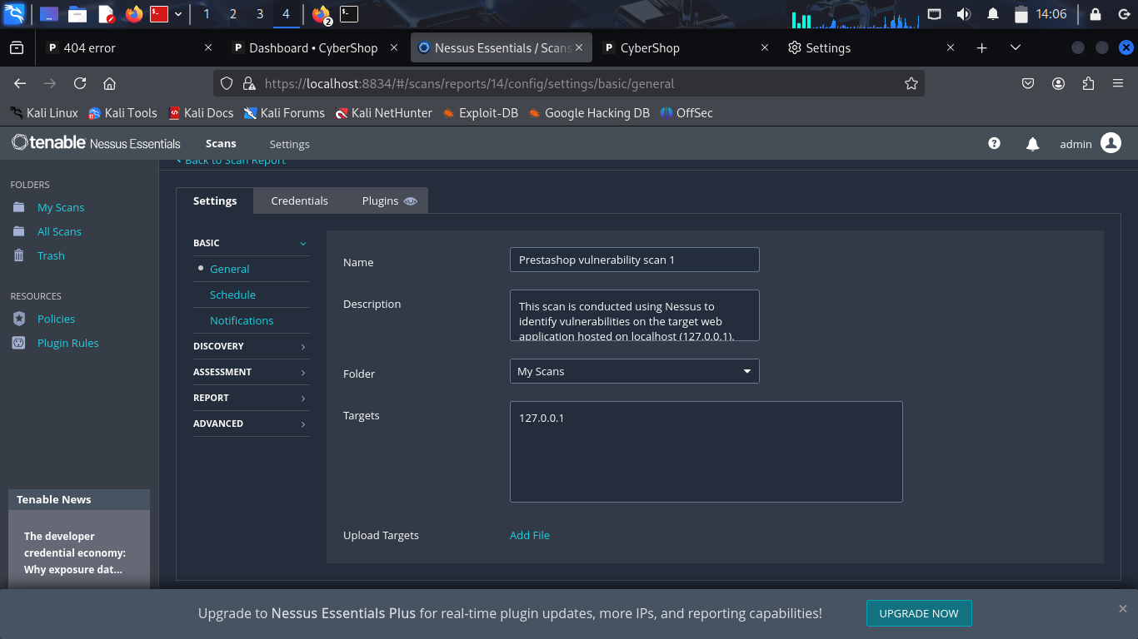
Figure 1: Vulnerability scan configuration targeting PrestaShop service on 127.0.0.1
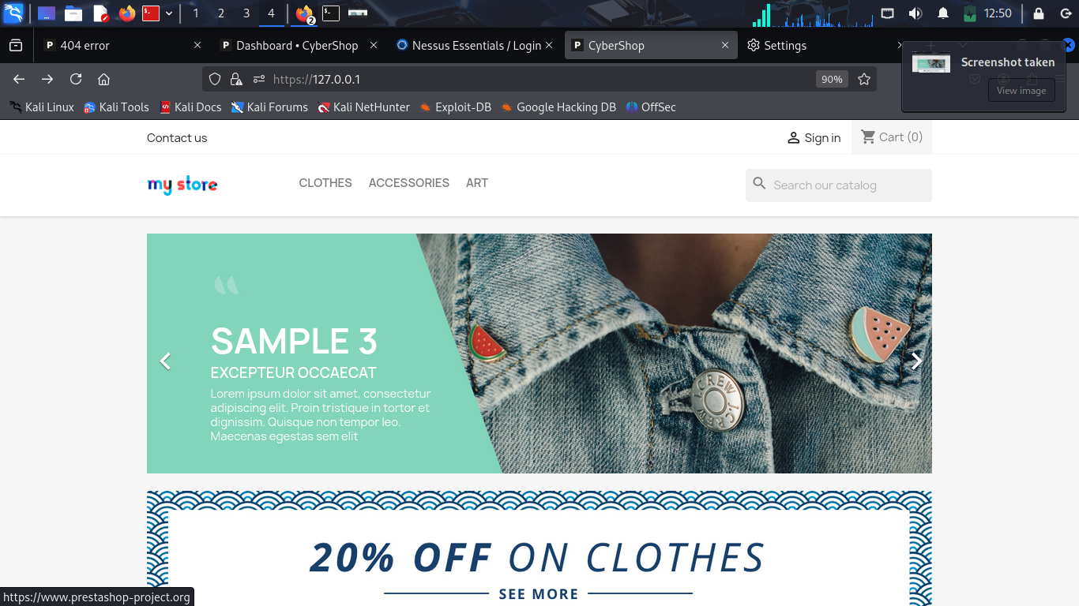
Figure 2: PrestaShop application interface accessed via HTTPS
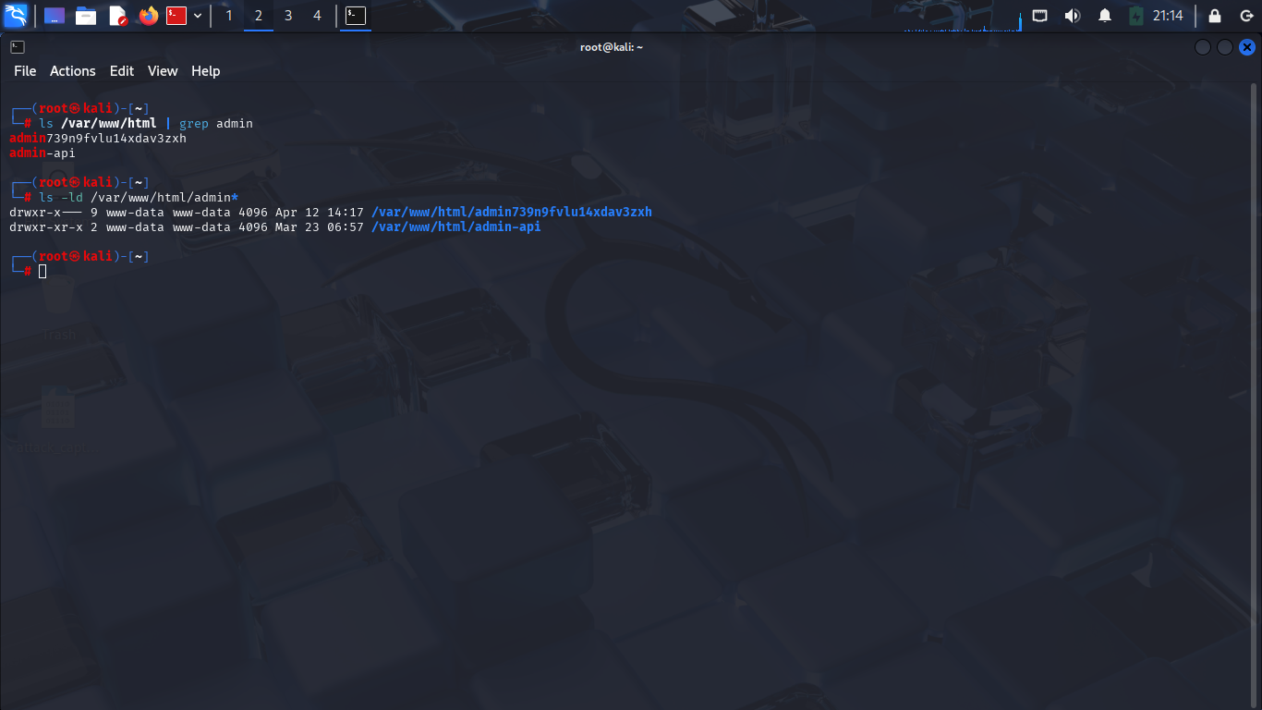
Figure 3: Renamed administrative directory (admin739n9fvlu14xdav3zxh).
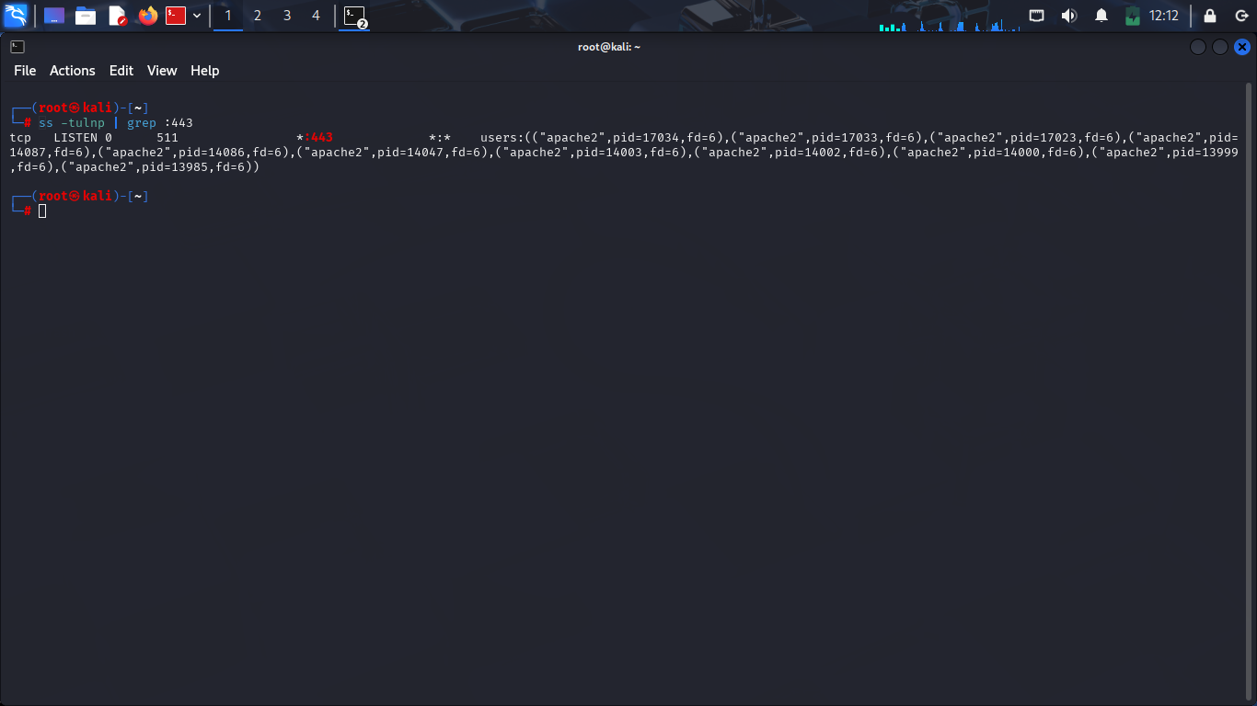
Figure 4: TLS verification showing active HTTPS on port 443 (ss -tulnp | grep :443)
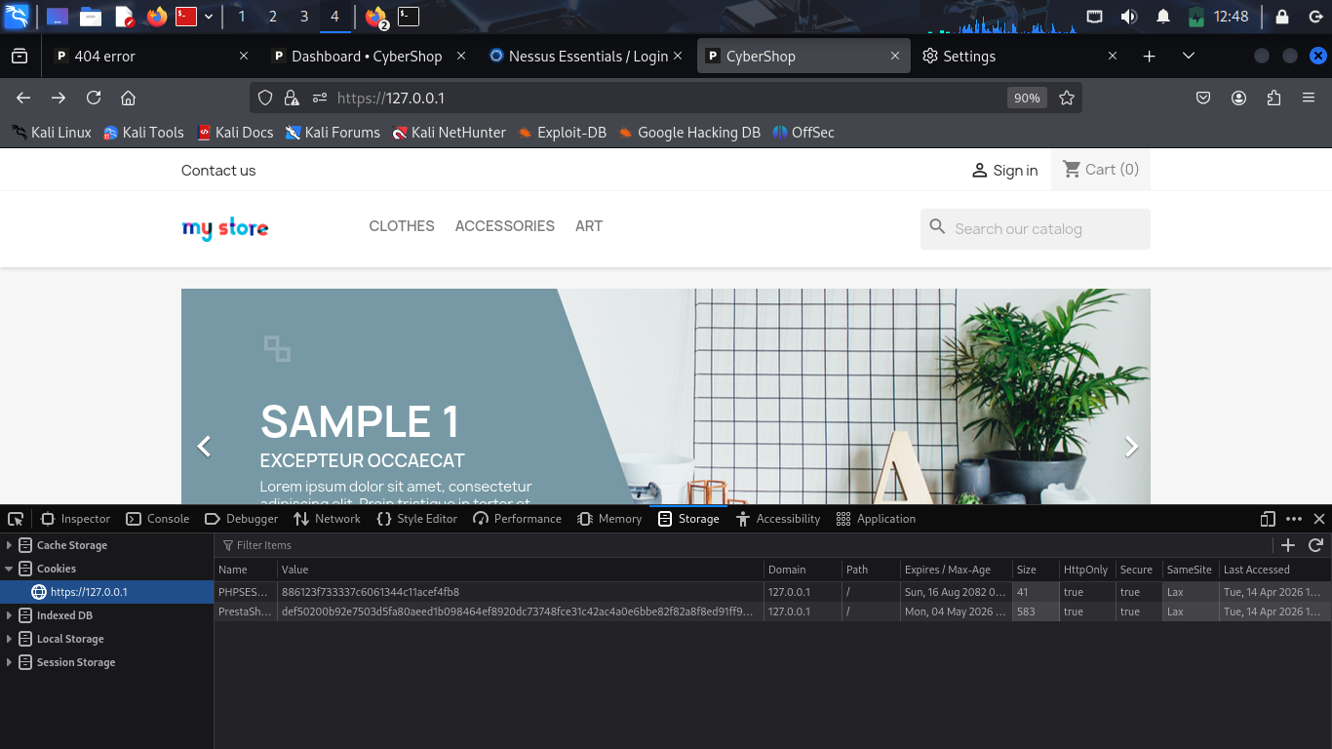
Figure 5: Cookie inspection showing Secure, HttpOnly, and SameSite=Lax attributes
Logs and Indicators
System logs were reviewed to monitor application and server activity during testing.
Relevant logs included:
- /var/log/apache2/access.log
- /var/log/apache2/error.log
Observed indicators included:
- HTTP/HTTPS requests to application endpoints
- Access attempts to administrative URLs
- PHP warning messages related to application initialization during misconfiguration testing
These logs demonstrate system visibility and support detection of unauthorized or suspicious access attempts.
Mitigation
The following mitigation measures were implemented to improve the security posture of the PrestaShop application:
- Enforced strong administrative authentication policies
- Renamed the default administrative directory to a non-predictable path
- Applied IP-based access restrictions to administrative endpoints
- Reviewed and restricted file and directory permissions
- Disabled unnecessary modules and plugins to reduce attack surface
- Enabled HTTPS (TLS) to secure communication between client and server
- Enforced secure session cookie attributes (Secure, HttpOnly, SameSite)
- Recommended deployment of a Web Application Firewall (WAF) such as ModSecurity
These measures significantly reduce the risk of unauthorized access and improve overall application security.
CONCLUSION
The attack simulation demonstrated that the implemented security hardening measures significantly reduced the attack surface of the PrestaShop application. Administrative access was secured through path obfuscation and access control, while transport-layer security and session protection were successfully enforced. Overall, the system demonstrated a strong security posture suitable for a controlled production-like environment.

